Objectives
Understand and articulate the rationale for Distributive Leadership
Analyze the key principles for Distributive Leadership and create a plan for implementation at the campus level
Agenda
  - Welcome, Introductions, and Norms
  - Rationale for Distributive Leadership
  - 5 Key Principles for Distributive Leadership
    - Roles and Responsibilities
    - Power Meetings
    - Leader Moves
  - Creating a Plan for Implementation
  - Questions and Adjourn
Rationale:
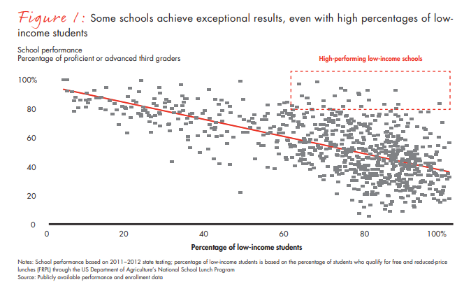
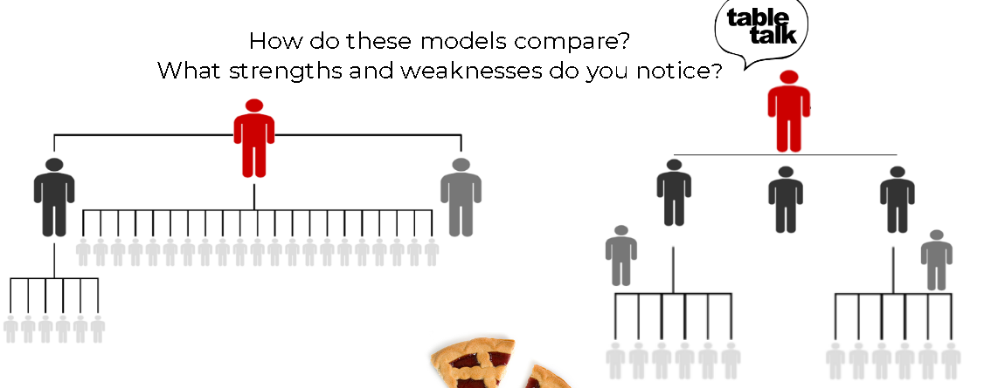
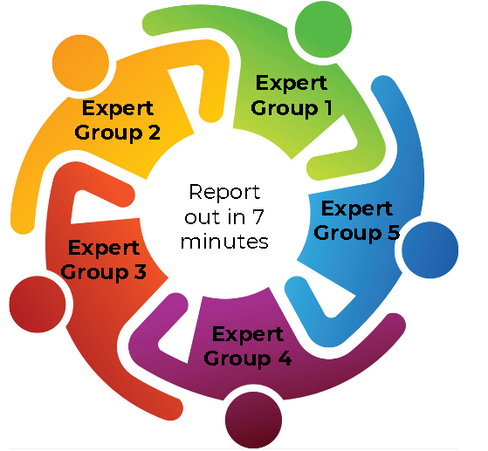
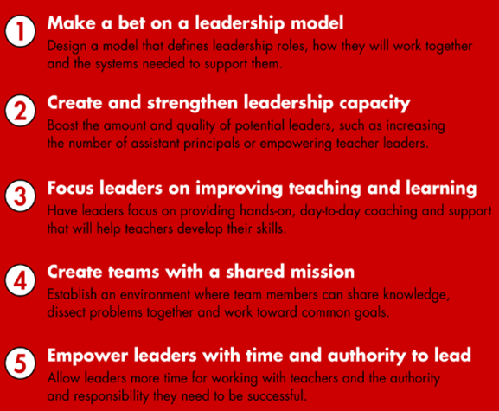
Roles and Responsibilities
TEAMS Model
Instructional and Operational Teams led by APs-
Instructional Team
CIC, and DC
Operational Team
Counselor
Team Leaders report to Principal and are coached and developed by principal
Team work towards goals with weekly collaboration
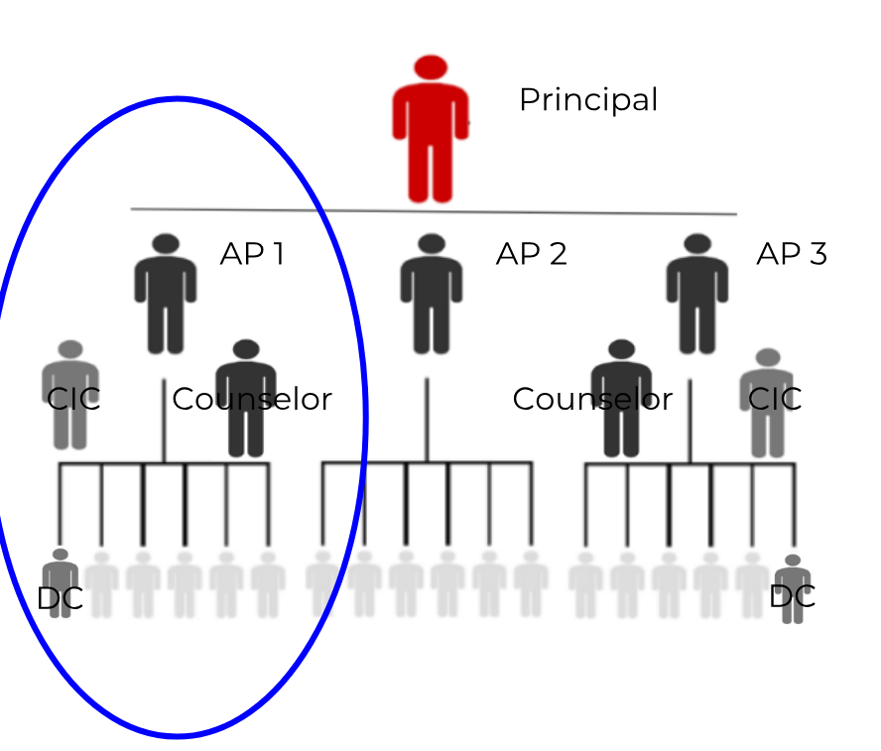
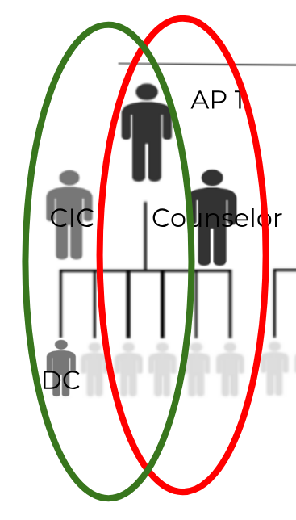
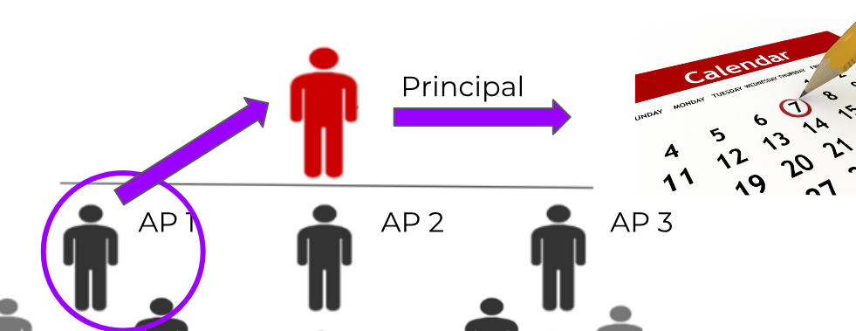

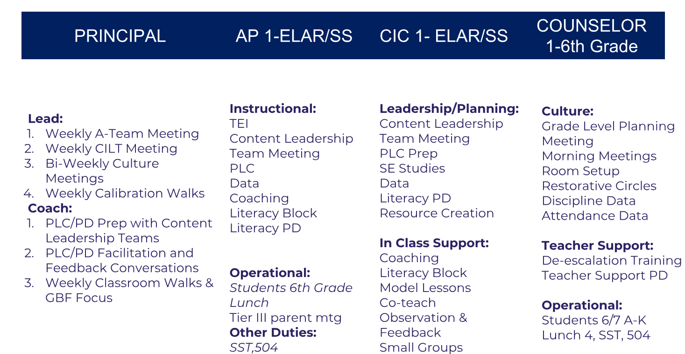
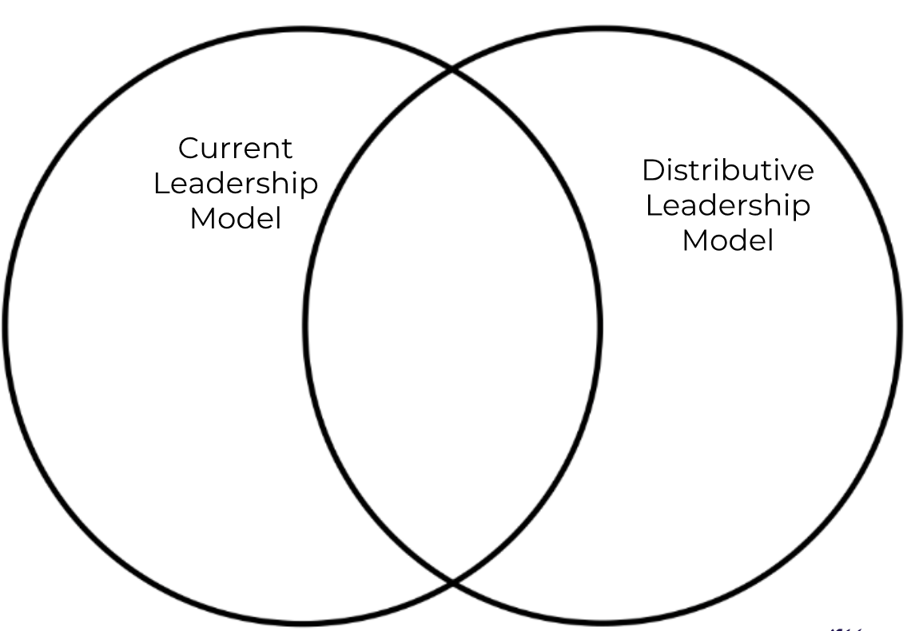
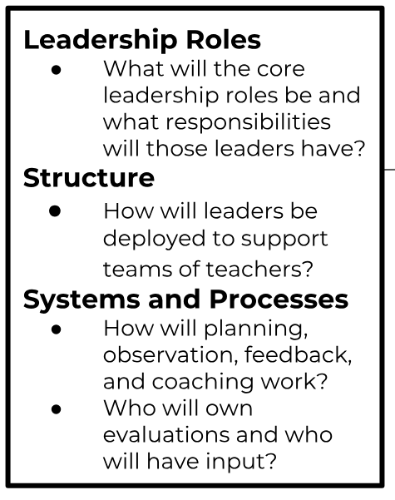
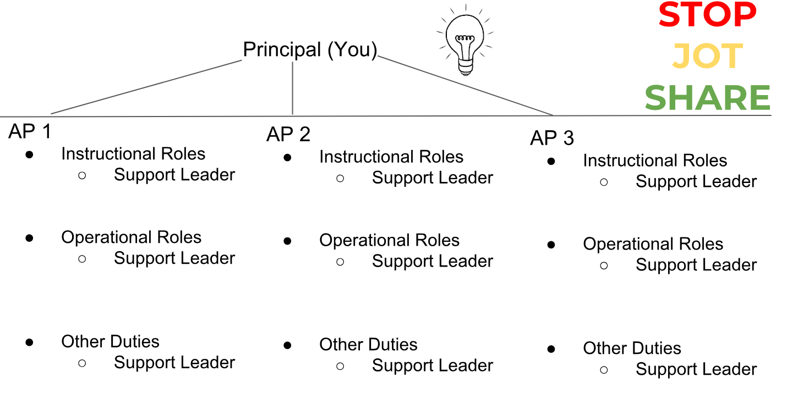
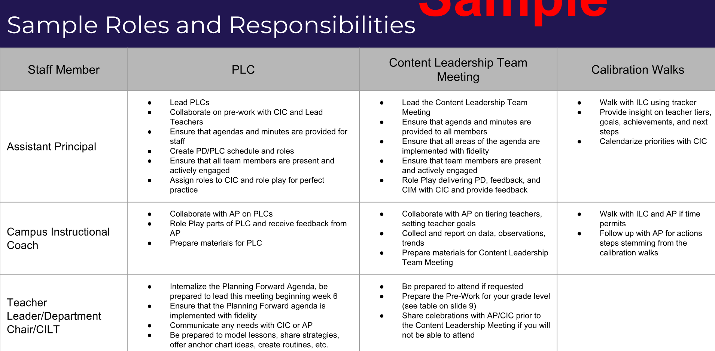

Roles and Responsibilities at Your Campus
How can you ensure that Team Leaders fully understand their roles, responsibilities, and take ownership of their piece of the “PIE”?

What tangible evidence will prove successful implementation of the Distributive Leadership Model?
Power Meetings
How can we create strong leaders that are capable of leading both instructional and operational teams with excellence?

- Clearly Defined Roles & Expectations
- Effective, Focused, Collaborative Meetings
  - A-Team
  - Content Leadership Team
  - PLC (Planning Forward and Looking Back)
- Calendarized Support from Principal
  - Perfect Practice
  - Coaching in the Moment
  - Observation and Feedback
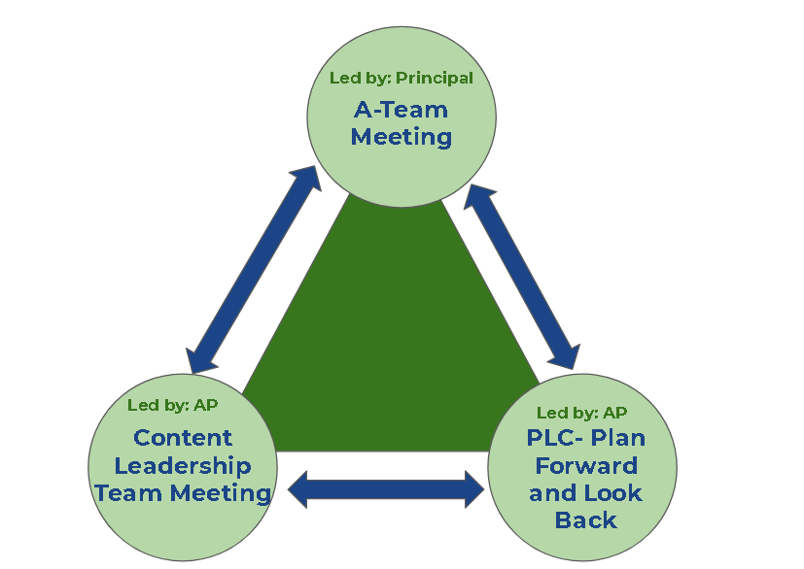

- A-Team Meeting
  - Review the A-Team Agenda with an elbow partner.
  - What would you add to this agenda to make it fit your campus needs?
  - How would you rearrange the order so that it flows better for you and your team?
- Content Leadership Team Meeting
  - Primary Functions
    - Plan for Planning Forward PLCs
    - Plan for Look Back PLCs
    - Tier Teachers and Establish Continual Growth Goals based on GBF
    - Track Teacher Progress on Goal Achievement
    - Create Coaching/Support Plans Specific to Teacher Needs
    - Create PD to Address Observations, and Data
    - Create Reports for A-Team
  - Review the Content Leadership Team Agenda and Planning Tool with your elbow partner.
  - How would effective Content Leadership Team Meetings impact students?

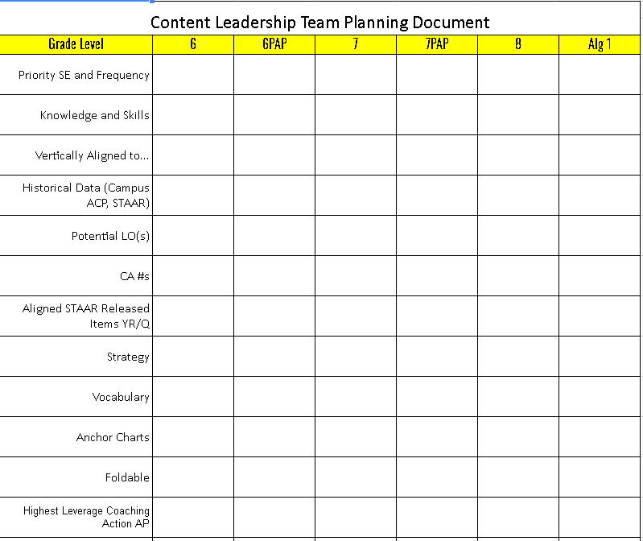
Review the sample agendas for each of the POWER Meetings. Create a PLUS/DELTA chart with your table.
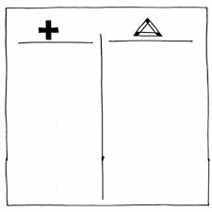
Revise the meeting agendas to fit your campus needs.
Address what is most important to you.
How will you measure?
Create checklists/rubrics with space for feedback
Leader Moves
Pre-Work
Clear Expectations
Ongoing
Goal Setting and Priorities
Build Capacity
Calendarizing
Roll-Out Plan
Steps to Setting Clear Expectations-
- Make them clear for yourself
- Know where you need expectations
- Understand why
- Meet and discuss
- Make it mutual
- Write them down
- Get agreement and commitment
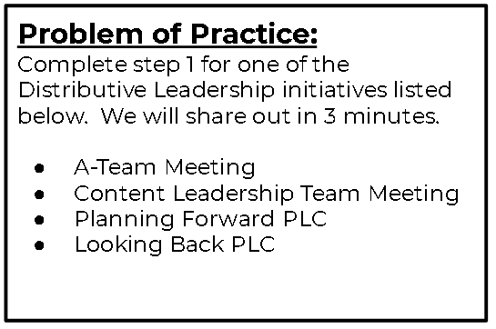
SMART GOALS
- Specific (simple, sensible, significant).
- Measurable (meaningful, motivating).
- Achievable (agreed, attainable).
- Relevant (reasonable, realistic and resourced, results-based).
- Time bound (time-based, time limited, time/cost limited, timely, time-sensitive)

Building Capacity
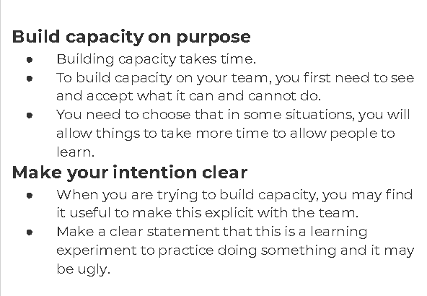
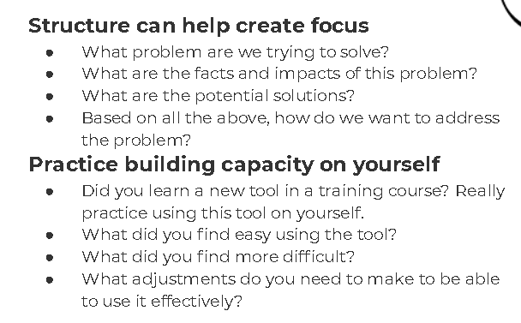

Calendarizing
In an 8 hour school day, that means over 5.5 hours are focused on instruction.

For this to occur, careful planning and execution of a prioritized calendar is required.

Using OUTLOOK, spend the last 5-10 minutes of each meeting calendarizing priorities.

All members of the A-Team will calendarize. A good practice is to share calendars among the team.

Leader Moves: Roll Out Plan Components
Principals will create the following components of the Campus Roll Out Plan and share them with their Executive Director by October 22, 2018.

- Organizational Flow Chart
- Roles and Responsibilities
  - Including Instructional/Organizational Teams
- Campus Power Meeting Schedule, Agendas, Protocols
  - A-Team Meeting
  - Content Leadership Team Meeting
  - PLC
    - Plan Forward/Look Back- for all STAAR Tested Grade Level/Contents
“Formative Assessments & Monitoring Student Progress” Core Ideas

