Weekly Data Meeting Training Handout

- Objective
  - Understand the critical attributes of Weekly Data Meetings, their rationale, and how to implement them in a PLC setting.
- Deliverables
  - Complete Guided Notes and Role Play as teacher.
  - Create implementation plan for your content area(s).
  - Video your Weekly Data Meeting and Score Yourself Using the WDM Rubric.
- Agenda
  - Welcome, Introductions, and Norms
  - Rationale for Weekly Data Meetings
  - 4 Key Components of Data-Driven Instruction
  - Role Play
    - Role Play- as teacher
    - Role Play- as leader
  - Weekly Data Meetings: Analysis and Action
    - Roles and Responsibilities
    - Pre-Work
      - Leader
      - Teacher
    - Campus Roll Out
  - Questions and Adjourn
Guiding Questions | Notes
What are the 4 Key Components to Strong Data Culture and Practices?
What do you know, want to learn or have questions about regarding the WDM Rubric?
Why are exemplars beneficial? How do you use them now? How will you use them moving forward?
Role Play Notes-
What are the key levers in Weekly Data Meetings? Why are they important? How did I feel during the role play? How will role play impact student achievement?
What pre-work is necessary? What is my role in pre-work? How does unpacking the standard and KNOW/SHOW charts help build teacher capacity?

ROLE PLAY Handout
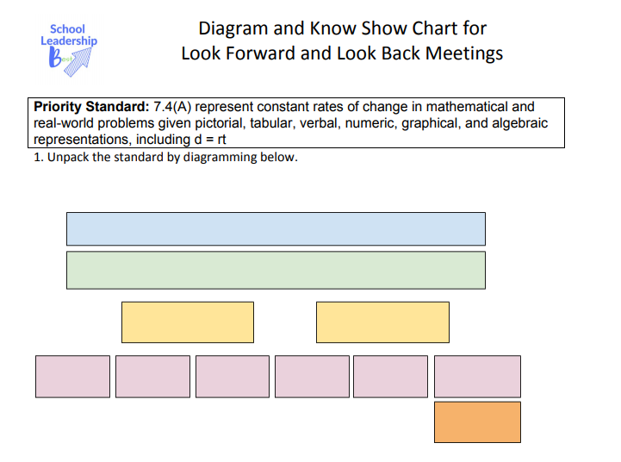
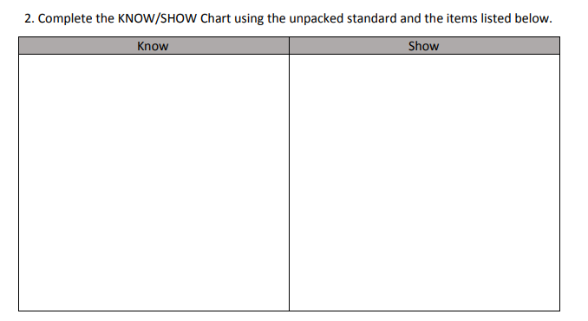

Common Assessment 2 (7.4A) Items
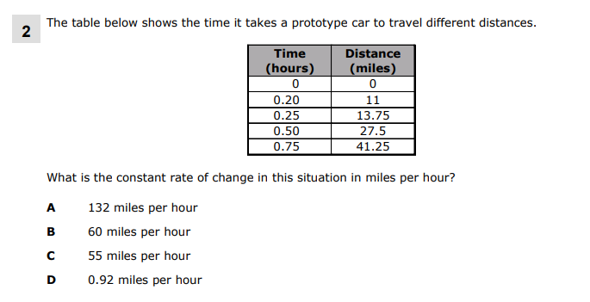
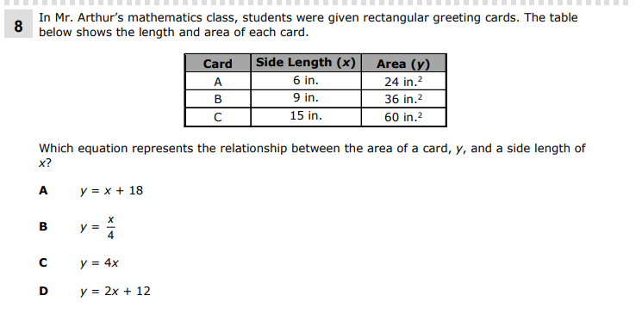

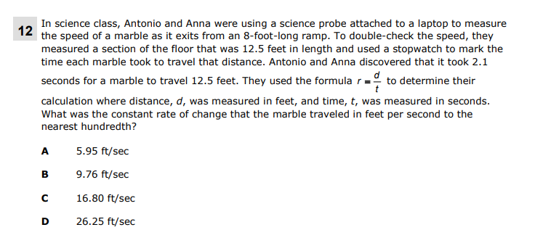

What is the highest leverage misconception?

Modeling or Guided Discourse?
Option 1: Guided Discourse  (some students struggle; trending error) | Guide Student Conversation
- Know the end game--what strategy/skill/thinking you want students to understand via the discourse
- Start from student work (Show-Call)
- Post/display/chart an exemplar student response AND/OR an incorrect student response
- Call on students—ID the student thinking:
- Exemplar: what did this student do?
    - Push for clearer answers when they haven’t precisely IDed the successful strategy
- Incorrect response: do you agree/disagree with this answer? What is the error?
- Stamp the understanding:
- What are the key things to remember when solving problems like these?
- Name the strategy/conceptual understanding; have students put it in their own words
Option 2:  Modeling  (Most students are struggling) | Show the Students How
- Model precisely the thinking when moving through a specific task:
- Narrow the focus to precisely the thinking students are struggling with: that frees their mind to focus only on that component
- Model replicable thinking steps that students can follow
- Model how to activate one’s content knowledge/skills that have been learned in previous lessons
- Vary in tone and cadence to sound different from a “teacher” voice.
- Give students a clear listening/note-taking task that fosters active listening of the model
- Debrief: What did I do in my model?
- What are the key things to remember when you are doing the same in your own work?
Reteach Assessment Items?

Strategies?

Anchor Charts?

Reteach DOL:
- In the uphill section of a 420 mile bike tournament, Charlotte traveled at a constant speed covering 25.6 miles in 72 minutes. Her coach used the formula, 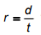 to determine Charlotte’s constant rate of change in this section of the bike tournament. What is Charlotte’s constant rate of speed in this section of the bike tournament in miles per hour?

- James and Charles used their allowance of $67 to purchase a 156 inch race track for their toy cars. They wanted to determine the constant rate of change of the toy cars as they traveled the length of the flat portion of the race track which was 18.75 inches in length. They found that it took 3.2 seconds for the cars to travel 18.75 inches. They used the formula, to calculate the constant rate of change. What is the constant rate of change for the toy cars on the flat portion of the race track in inches per second?
- A giant tortoise travels at a constant rate and covers 2.5 miles in 20.2 hours. What is the tortoise constant rate of change in miles per hour to the nearest hundredth?

Write your script.
If a model: write the think aloud and questions
If guided discourse: select student work for show-call, write prompts

Compare Reteach Plans with your partner. What do you notice? What can we pull from each to make the strongest plan?” (Revise the plan)

Plan the independent practice:

What will you monitor to see if they are doing this correctly?

What Aggressive Monitoring laps will you name?
Lap 1:
Lap 2:
Lap 3:

When is the reteach?

When will we review the data from the reteach assessment?

What will I do if students do not master 7.4A after the reteach?

