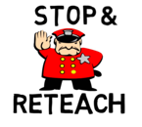
Reteach Lesson Review Reflection:

Effective Feedback Model
Feedback Component | Observations
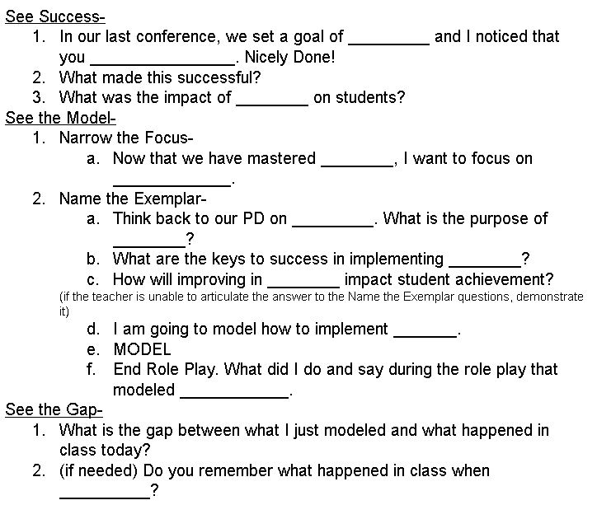
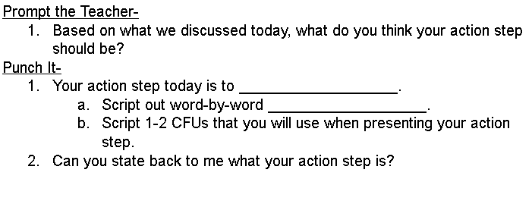
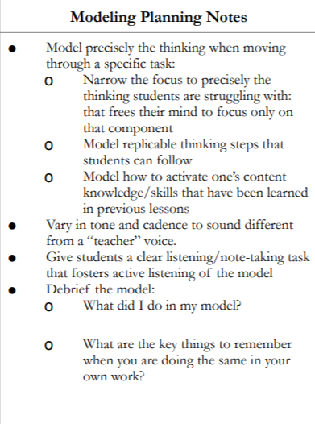
Reteach Video Observation Notes

Reteach Feedback Plan
Feedback Component | Script
“Formative Assessments & Monitoring Student Progress” Core Ideas

Aggressive Monitoring
Prerequisites→
- Teachers have mastered ___________________________________ , ________________________________________, and __________________________________ from the Bambrick-Santoyo Waterfall Rigor Trajectory.
Prework →
- Teachers have created a ______________within their classroom such that high performing students will be the first students interacted with during each lap, followed by average performing students and then lower performing students.
- Teachers have created a __________________________________ that they will use with students. Students know what the symbols in the coding system mean. (An anchor chart is visible to students with symbols and meanings).
- Teachers have ____________________________ of the class.
- Teachers have created an _______________ of all student work.
- Teachers have _____________________________________________ objectives for each section of the lesson cycle.

Implementation →
- During each section of the lesson cycle, the teacher will review student work, provide students with written feedback, and collect qualitative data to inform instructional decisions.
  - The teacher will round to aggressively monitor:
    - Announce the ___________________________________
    - Follow the ___________________ of highest performing to lowest performing student
    - Provide _____________________ to students using the established coding system
    - Collect qualitative data to inform instructional decisions
  - The teacher will respond to the data from their monitoring:
    - If the teacher __________notices 2-3 students with the same error, the teacher will stop and address the misconception with the whole class using _____________________________.
    - If the teacher notices only a few students with the same error, the teacher will pull a quick __________ _______________.
    - Qualitative data that is collected is used to inform _________________________________ about whole group and small group reteach decisions based on the collected data.

Aggressive Monitoring Model Part I
Notes:

Aggressive Monitoring Model Part II
Notes:

